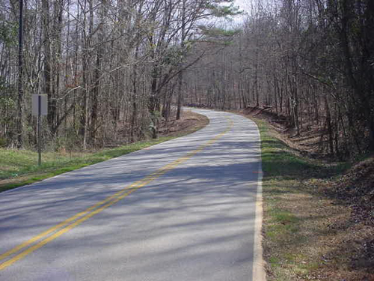

Before

**The Ohio LTAP Center**

**Rural Road Safety Audit Assistance Program Guidebook**

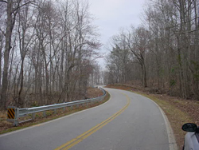

After

Table of Contents

Executive Summary 5

Routes Proposed for Review 7

Team Charter –Rural Road Safety Audits Assistance (RRSAA) Program Partnership between the Shelby County Engineer’s Office (SCEO) and the Ohio LTAP Center 33

Timeframe for Project Completion 36

Steps for Conducting a Road Safety Audit 37

Funding Percentages for Improvements 38

# Executive Summary

The Ohio Department of Transportation’s Safety Program within the Office of Systems Planning and Program Management, under direction from the United States Congress and the Federal Highway Administration, administers the High Risk Rural Roads (HRRR) program for the State of Ohio. As a part of this program, the ODOT Safety Program has partnered with the Ohio LTAP Center to provide assistance to Counties and Townships containing corridors with accident rates for fatalities and incapacitating injuries exceeding the statewide average for the identified functional class of roadway.[1]

Based upon the criteria outlined in the HRRR program, the ODOT Safety Program has identified corridors within Shelby County where the Ohio LTAP Program can partner with the Shelby County Engineer’s Office (SCEO) to provide Roadside Safety Audit assistance to lower the accident rates for fatalities and lower the number of incapacitating injuries on the targeted roadways. The Ohio LTAP Center would partner with SCEO to:

* Review the identified corridors and reach agreement concerning which corridors from the target list will be addressed as a part of this program.[2]
* Build a team of community members – SCEO staff, law enforcement staff, members of the traveling public who frequent the identified corridors, etc., to participate in a Rural Road Safety Audit led by the SCEO and staff members from Ohio LTAP.
* Schedule and complete the Rural Road Safety Audits with the aforementioned team.
* Utilize the information from the completed Rural Road Safety Audit to create a findings report in partnership with the Ohio LTAP center’s report writer.
* Complete a grant application with the assistance of the Ohio LTAP Center’s grant writer for 90% or possible 100%[3] funding of the recommended safety improvements by ODOT Safety Program.
* If the grant application is approved, assistance will also be provided by the Ohio LTAP Center’s staff to SCEO to complete all documentation required under the terms and conditions of the grant from the ODOT Safety Program.

The ODOT Safety Program encourages SCEO to take full advantage of the Ohio LTAP Center’s assistance to address these high concern corridors through the available HRRR funding.



# Routes Proposed for Review



* Shelby County – SHE-CR-45 County Road 45.
  + Rated #1 on the 2006-2010 data analysis in the State of Ohio under the formula[4] utilized by the ODOT Safety Program

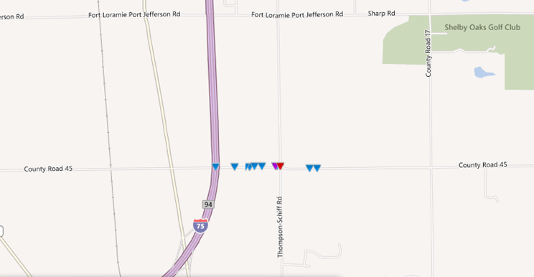

**Image 1 – SHE-CR-45**

**Chart 1 – SHE-CR-45Frequency of Crashes by Year**

**Chart 2 – SHE-CR-45Frequency of Crashes by Year and Severity**

**Chart 3 – SHE-CR-45Frequency of Crashes by Hour**

* Shelby County – SHE-CR-26 – W. Mill Creek Road
  + Rated # 12 on the 2006-2010 data analysis in the State of Ohio under the formula[5] utilized by the ODOT Safety Program

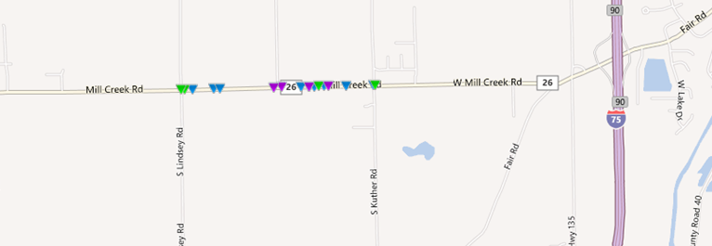

**Image 2 – SHE-CR-26**

**Chart 4 – SHE-CR-26 Frequency of Crashes by Year**

**Chart 5 – SHE-CR-26 Frequency of Crashes by Year and Severity**

**Chart 6 – SHE-CR-26 Frequency of Crashes by Hour**

* Shelby County – SHE-CR-25A: Sidney-Wapakonetta Road
  + Rated #18 on the 2006-2010 data analysis in the State of Ohio under the formula[6] utilized by the ODOT Safety Program

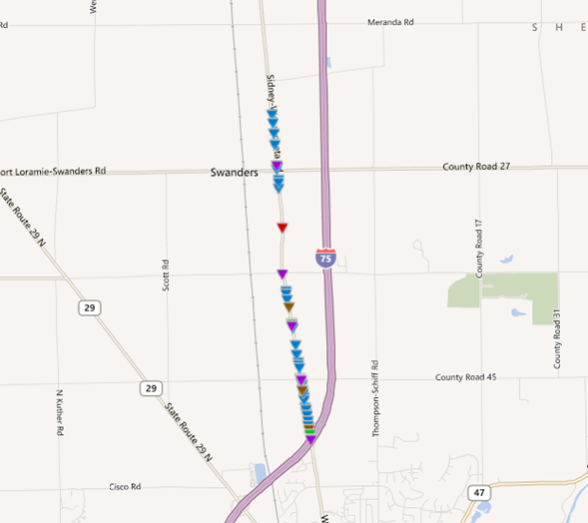

**Image 3 – SHE-CR-25A**

**Chart 7 – SHE-CR-25A Frequency of Crashes by Year**

**Chart 8 – SHE-CR-25A Frequency of Crashes by Year and Severity**

**Chart 9 – SHE-CR-25A Frequency of Crashes by Hour**

* Shelby County – SHE-CR-8: Fair Road
  + Rated #72 on the 2006-2010 data analysis in the State of Ohio under the formula[7] utilized by the ODOT Safety Program

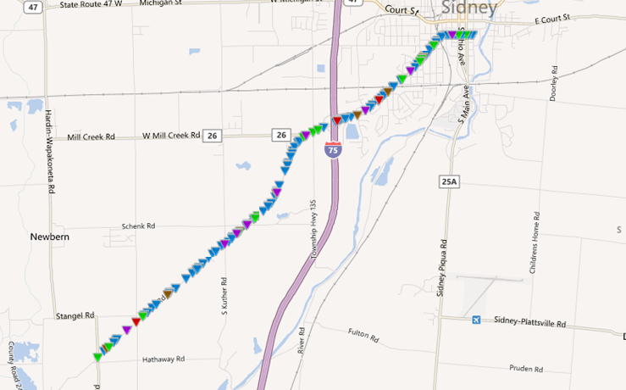

**Image 4 – SHE-CR-8**

**Chart 10 – SHE-CR-8 Frequency of Crashes by Year**

**Chart 11– SHE-CR-8 Frequency of Crashes by Year and Severity**

**Chart 12 – SHE-CR-8 Frequency of Crashes by Hour**

* Shelby County – SHE-CR-22: Botkins Road
  + Rated #81 on the 2006-2010 data analysis in the State of Ohio under the formula[8] utilized by the ODOT Safety Program

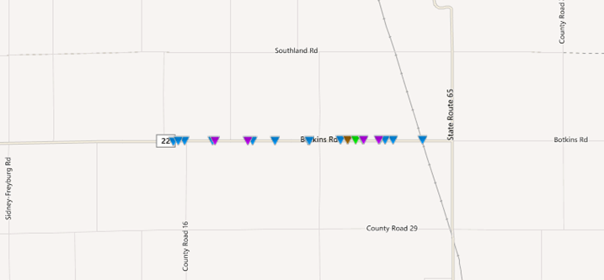

**Image 5 – SHE-CR-22**

**Chart 13 – SHE-CR-22 Frequency of Crashes by Year**

**Chart 14– SHE-CR-22 Frequency of Crashes by Year and Severity**

**Chart 15 – SHE-CR-22 Frequency of Crashes by Hour**

# Team Charter –Rural Road Safety Audits Assistance (RRSAA) Program Partnership between the Shelby County Engineer’s Office (SCEO) and the Ohio LTAP Center

|  |  |  |  |  |  |  |  |
| --- | --- | --- | --- | --- | --- | --- | --- |
| **Mission Statement:**  To collect and compile the information on the five qualifying rural corridors for the SCEO to apply for High Risk Rural Roads funding for implement low-cost safety improvements. | | | | | | | **Today’s Date:**  6/12/2012 |
| **Scope Statement:**  Working under the guidance of the ODOT Safety Program, the SCEO and the Ohio LTAP program shall form a multidisciplinary team and then utilizing documented Road Safety Audit methodology, complete Roadway Safety Audits on five identified Shelby County Routes (SHE-CR-45, SHE-CR-26, SHE-CR-25A, SHE-CR-8 and SHE-CR-22). Once the RSAs have been completed, the Ohio LTAP office will compile the collected information and assist the SCEO in applying for HRRR funding to implement low-cost safety improvements for the reviewed routes. If the application is approved, the Ohio LTAP program will provide assistance to the SCEO in completing the post grant funding paperwork. | | | | | | | |
| **Project Deliverable:**  Application for funding by the SCEO to the Ohio Safety Program for utilization of HRRR funding to implement low-cost safety improvements along the five identified rural corridors. | | | | | | | |
| **Team Sponsor(s):** (the individual(s) who own the process and have the authority to approve/implement changes):  ROBERT B. GUEY & MICHELLE MAY | | | | | **Sponsor(s) Phone and E-mail:**  937-498-7244  [rbg@shelbycountyengineer.com](mailto:rbg@shelbycountyengineer.com)  614-644-8309  [MICHELLE.MAY@DOT.STATE.OH.US](mailto:MICHELLE.MAY@DOT.STATE.OH.US) | | |
| **Team Facilitator(s):**  Victoria Beale | | | | | **Team Facilitator(s) Phone and E-mail:**  614-466-3129 | | |
| **Member Name:** | **Location:** | | **Phone:** | | **E-mail:** | | |
| Nick Miller | Shelby County Engineer’s Office | |  | |  | | |
| Tim Bender | Shelby County Sheriff’s Office | |  | |  | | |
| Mark Wiss | Shelby County Engineer’s Office | |  | |  | | |
| **Subject Matter Expert Group** | | | | | | | |
| **Name** | | **Location** | | | | **Phone** | |
| Michelle May | | 1980 W. Broad St., Columbus, OH 43223 | | | | 614-644-8309 | |
| Robert B. Guey | | 500 Gearhart Road, Sidney, OH 45365 | | | | 937-498-7244 | |
| Jonathan Hughes | | 1980 W. Broad St., Columbus, OH 43223 | | | | 614-466-4019 | |
| Craig Eley | | 1001 St. Mary’s Avenue, PO Box 969, Sidney, OH 45365 | | | | 937-497-6832 | |
| **Date of 1st Meeting:**  (completed by team meeting): | | | | **Est. Date of Completion:** (completed by sponsor): | | **Actual Completion Date:** (completed by team): | |
| **Team Leader:**  Victoria Beale | | | | **Team Sponsor’s Signature/Date:** | | **Team Sponsor’s Signature/Date:** | |

# 

# Timeframe for Project Completion

* Initial Data Compilation for Accident Locations
  + 2 weeks
* Meeting with County Engineer
  + 1 week
* Chartering Team
  + 2 weeks
* Team Training
  + 1 week
* Assessment of Sites
  + 2 weeks
* Recommendations Report
  + 2 weeks
* Project Documentation Assistance
  + Dependent upon length of project

Time commitment: 3 months (not including final step of process)

# Steps for Conducting a Road Safety Audit

The following is an outline of the steps which the multidisciplinary team will be following when completing the Road Safety Audits (RSA):

1. Preparation
   1. Initial Meeting
      1. Discussion of why
         1. The SCEO and the Ohio LTAP center have teamed up to complete the reviews of the qualifying roadways
         2. They have been invited to be part of the multidisciplinary team
         3. The RSA process
            1. Team review times
            2. Equipment to be utilized
            3. Resources/Subject Matter Experts which/who will be available
      2. Review of
         1. Accident information per corridor
      3. Next Steps
         1. Schedule coordination for RSA team physical reviews of locations
         2. Determination of meeting time to compile recommendations report (recommend immediate following physical reviews)
   2. RSA Team Physical Reviews
      1. Conduct field inspection of the roads and determine if and what changes should be recommended to improve the roadway’s safety
      2. Standard recommended visit times:
         1. Morning peak travel time
         2. Noon peak travel time
         3. Afternoon peak travel time
         4. Night peak travel time
      3. Complete the reviewer field documentation guide during the various physical reviews
   3. Recommendations Meeting
      1. After the physical field reviews are completed, the team will meet to
         1. Compile issues identified
         2. Possible recommendations
      2. The team will then rank and prioritize the recommendations so the information can be utilized by the SCEO and the Ohio LTAP center in preparing the recommendations report and grant application to the ODOT Safety Program for possible High Risk Rural Roads (HRRR) safety improvements funding

# Funding Percentages for Improvements

The following items are eligible for 100% Federal Funding when approved as part of a safety improvement project:

* Pavement markings
* Installation of traffic signs
* Traffic lights
* Guardrails
* Impact attenuators
* Concrete barrier end treatments
* Breakaway utility poles
* Traffic controlled signalization
* Traffic circles (roundabouts)
* Safety rest areas
* Commuter carpooling and van pooling
* Rail-highway crossing closure
* Priority control systems for emergency vehicles or transit vehicles at signalized intersections

All other approved safety improvements are eligible for funding at 90% Federal Funds with a 10% match by the local agency.

1. 23 CFR 148 (a)(1)(A)
2. Targeted corridors were selected based upon raking in the top 100 high risk rural roads from calendar year 2006 to 2010.
3. 23 USC 120 and 23 USC 130 provide guidance on what may be funded at 100% under the High Risk Rural Roads program.
4. *Total crash rate times (severity cost divided by crash type cost) times total crashes equals the Hazard Value 1 (HV1)*
5. *Total crash rate times (severity cost divided by crash type cost) times total crashes equals the Hazard Value 1 (HV1)*
6. *Total crash rate times (severity cost divided by crash type cost) times total crashes equals the Hazard Value 1 (HV1)*
7. *Total crash rate times (severity cost divided by crash type cost) times total crashes equals the Hazard Value 1 (HV1)*
8. *Total crash rate times (severity cost divided by crash type cost) times total crashes equals the Hazard Value 1 (HV1)*